Ref:
SQL Table Partitioning (Visually Explained) | Optimize Big Table Performance | #SQL Course 42
Data with Baraa
https://www.youtube.com/watch?v=tQQ3XwrKbfM

To Optimize the performance of BIG Tables
- Indexing
- Partitioning –Dividing big tables into smaller partitions while still being treated as a single Logical Table

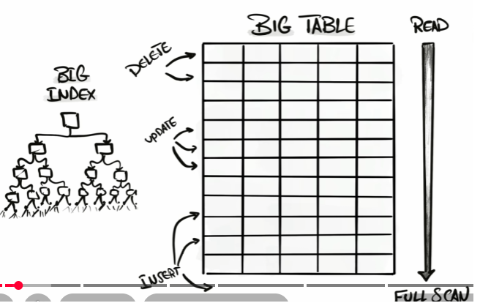

With indexing, as shown above, lot of clusters are created and it will hit the performance during Insert, Update and delete operations.
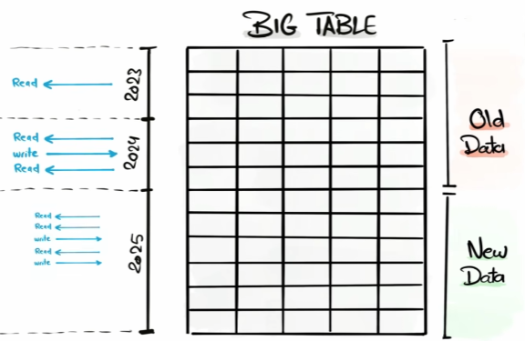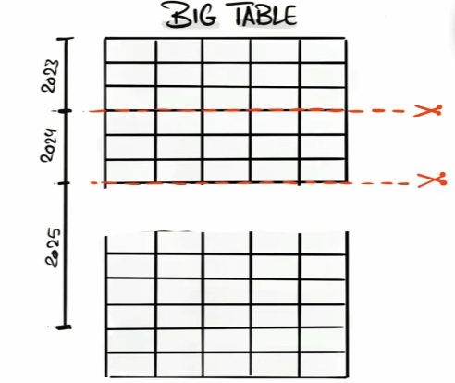

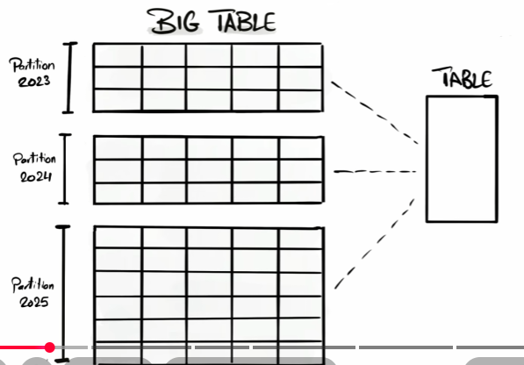

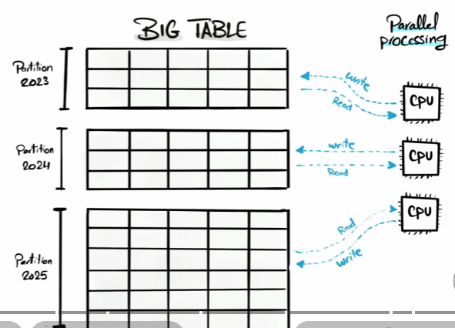
Partitioning with Indexing More powerful performance
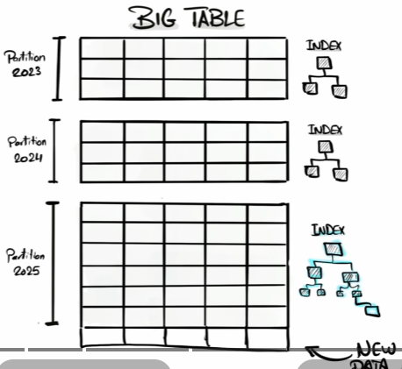

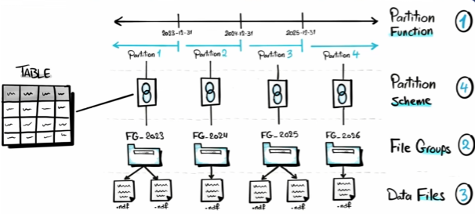

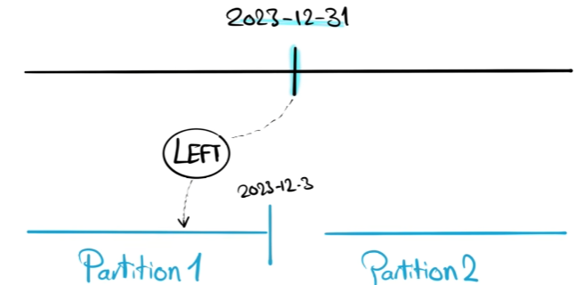
SQL Implementation:

- Create a partition function

create partition function partitionbyyear (date)
as range left for values ('2023-12-31','2024-12-31','2025-12-31')

- List all the available partition functions

select name,function_id,type,type_desc,boundary_value_on_right
from sys.partition_functions

Building Partitions
- Create Filegroups
Filegroups Logical container of one or more data files to help organize partitions

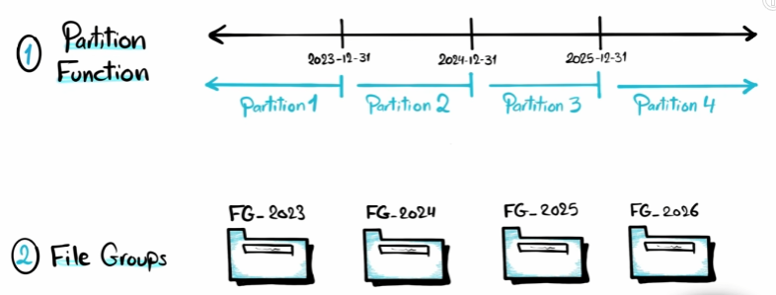

Alter database ELGI_LN add filegroup FG_2023;
Alter database ELGI_LN add filegroup FG_2024;
Alter database ELGI_LN add filegroup FG_2025;
To Remove:
Alter database ELGI_LN remove filegroup FG_2023;
Alter database ELGI_LN remove filegroup FG_2024;
Alter database ELGI_LN remove filegroup FG_2025;

- List all the available filegroups
select * from sys.filegroups where type='FG'
Note: There will be a Primary filegroup created for each database by default
- Create DataFiles
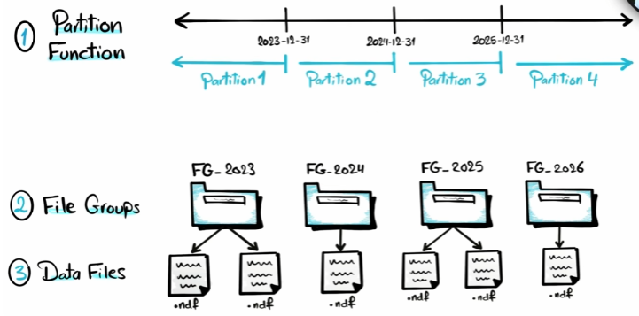

.ndf files are secondary data files.
There can be any number of datafiles for a filegroup

Alter database ELGI_LN add file
(
name='F_2023', --Logical name
filename='F:\data\F_2023.ndf'
)To filegroup FG_2023;
Alter database ELGI_LN add file
(
name='F_2023', --Logical name
filename='F:\data\F_2023.ndf'
)To filegroup FG_2024;

Alter database ELGI_LN add file
(
name='F_2023', --Logical name
filename='F:\data\F_2023.ndf'
)To filegroup FG_2025;

select fg.name as FilegroupName,
mf.name as LogicalFileName,
mf.physical_name as PhysicalFilePath,
mf.size/128 as SizeinMB
from sys.filegroups fg
left outer join sys.master_files mf
on fg.data_space_id=mf.data_space_id
where mf.data_space_id=DB_ID('ELGi_LN');

- Creating Partition schema

Mapping each partition to the respective file group

create partition scheme schemePartitionbyYear
as partition partitionbyyear
to (FG_2023,FG_2024,FG_2025)

Note: No of partitions = No of Filegroups
No of Boundaries = No of Partitions -1
Make sure the Filegroups are mapped in correct order else partition 1
can be mapped to Filegroup2 and provides incorrect results

List all Partition Schemes:

select
ps.name as PartitionSchemeName,
pf.name as PartitionFunctionName,
ds.destination_id as PartitionNumber,
fg.name as FileGroupName
from
sys.partition_schemes ps
left outer join sys.partition_functions pf
on ps.function_id=pf.function_id
left outer join sys.destination_data_spaces ds
on ps.data_space_id=ds.data_space_id
left outer join sys.filegroups fg
on ds.data_space_id=fg.data_space_id

- Create Partitioned table

create table ELGI_sales_details_Partitioned
(
company int,
trantype varchar(25),
invoice varchar(25),
Invoice_date date
)on schemePartitionbyYear(Invoice_date)

Insert into ELGI_sales_details_Partitioned values
(401,'s10','1001','2023-10-01'),
(401,'s10','1001','2024-10-01'),
(401,'s10','1001','2025-10-01')

Check where these records are mapped in the Filegroups
select
p.partition_number as PartitionNumber,
fg.name as PartitonFileGroup,
p.rows as NoOfRows
from sys.partitions p
left outer join sys.destination_data_spaces dds
on p.partition_number=dds.data_space_id
left outer join sys.filegroups fg
on dds.data_space_id=fg.data_space_id
where OBJECT_NAME(p.object_id)='ELGI_sales_details_Partitioned'

To get the partition information
Database Database Name Storage Partition Schemes
Database Database Name Storage Partition Functions

How to check the Performance
Create a mirror of the partitioned table and execute in a separate window and compare the performance
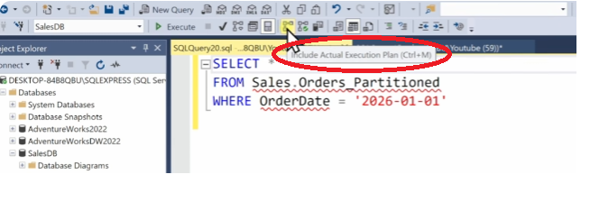
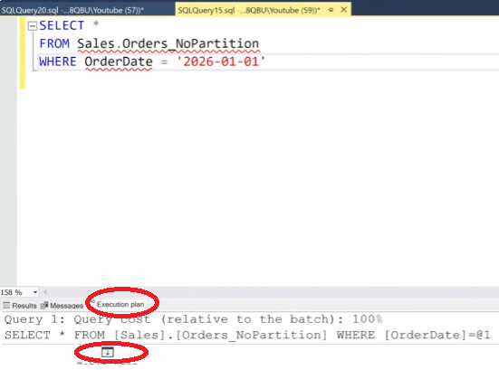
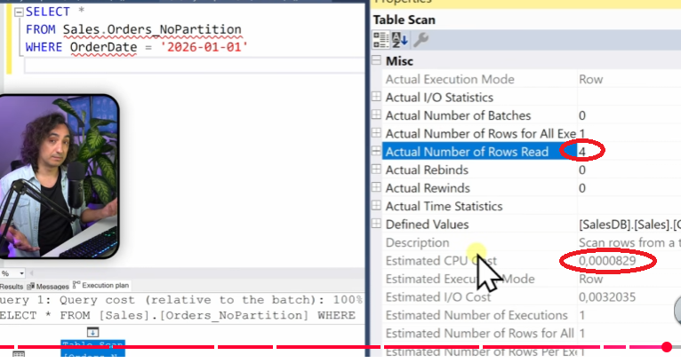

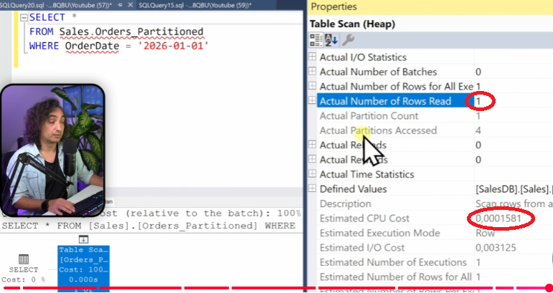

A clustered index determines the physical order in which rows are stored in a table. Because the data itself is organized according to the clustered index key, a table can have only one clustered index.
How it works
Suppose you have this table:
OrderID | OrderDate | CustomerID | Amount
105 | 2025-01-10 | 12 | 500
101 | 2024-12-15 | 15 | 300
103 | 2025-01-02 | 20 | 700
If you create a clustered index on OrderID:
CREATE CLUSTERED INDEX IX_Orders_OrderID
ON Orders(OrderID);
The rows are physically stored in this order:
OrderID | OrderDate | CustomerID | Amount
101 | 2024-12-15 | 15 | 300
103 | 2025-01-02 | 20 | 700
105 | 2025-01-10 | 12 | 500
This makes searches and range queries on OrderID very efficient.
Clustered vs. Nonclustered Index
Clustered Index | Nonclustered Index
Stores the actual table rows in key order | Stores the index separately from the table
Only one per table | Multiple can exist on a table
Good for range scans | Good for lookups on various columns
Leaf level contains the actual data pages | Leaf level contains key values and row locators
When to use a clustered index
A clustered index is a good choice for columns that:
- Are frequently used in range queries (BETWEEN, >, <)
- Are unique or nearly unique
- Change infrequently
- Are used for sorting (ORDER BY)
Common examples include:
- OrderID
- OrderDate
- TransactionDate
Clustered index and primary key
When you create a primary key:
CREATE TABLE Orders
(
OrderID INT PRIMARY KEY,
OrderDate DATE,
Amount DECIMAL(10,2)
);
SQL Server creates a clustered index on OrderID by default, unless:
- A clustered index already exists, or
- You explicitly specify NONCLUSTERED.
Clustered index and partitioning
For partitioned tables in SQL Server, the clustered index is commonly created on the partition scheme. The partitioning column must be part of the clustered index key. For example:
CREATE CLUSTERED INDEX IX_Orders
ON Orders(OrderDate, OrderID)
ON PS_OrderDate(OrderDate);
Here:
- OrderDate is the partitioning column.
- The table is physically partitioned by OrderDate.
- Within each partition, the rows are ordered by the clustered index key.
Checking clustered indexes
To see the indexes on a table:
EXEC sp_helpindex 'Orders';
Or:
SELECT
i.name,
i.type_desc
FROM sys.indexes AS i
WHERE i.object_id = OBJECT_ID('Orders');
The type_desc value will indicate whether an index is CLUSTERED or NONCLUSTERED.
Example
Imagine an Orders table with 100 million rows. If you frequently run:
SELECT *
FROM Orders
WHERE OrderDate BETWEEN '2026-01-01' AND '2026-01-31';
A clustered index on OrderDate (or a partitioned clustered index using OrderDate) allows SQL Server to efficiently locate and scan the relevant rows, rather than scanning the entire table.
if the table doesn't have a primary key, can we create a clustered index
Yes. A table does not need a primary key to have a clustered index. A primary key and a clustered index are separate concepts in SQL Server.
For example, suppose you have a table without a primary key:
CREATE TABLE Employees
(
EmployeeID INT,
EmployeeName VARCHAR(100),
HireDate DATE
);
You can create a clustered index on EmployeeID:
CREATE CLUSTERED INDEX IX_Employees_EmployeeID
ON Employees(EmployeeID);
This physically orders the table by EmployeeID, even though there is no primary key.
Primary Key vs. Clustered Index
Primary Key | Clustered Index
Enforces uniqueness | Determines physical storage order
Cannot contain NULLs | Can be unique or non-unique
One per table | One per table
By default creates a clustered index (if one doesn't already exist) | Can exist independently of a primary key
Can a clustered index be non-unique?
Yes.
For example:
CREATE CLUSTERED INDEX IX_Employees_Department
ON Employees(DepartmentID);
If multiple employees belong to the same department, SQL Server automatically adds a hidden uniqueifier to distinguish duplicate key values internally.
Best practices
Choose a clustered index on a column that:
- Is frequently used in WHERE clauses or joins.
- Is relatively stable (doesn't change often).
- Has increasing values if possible (such as an identity column or a timestamp) to reduce page splits.
- Is narrow (uses fewer bytes).
For partitioning
If your goal is to partition the table, the clustered index should include the partitioning column. For example:
CREATE CLUSTERED INDEX IX_Sales
ON Sales(TransactionDate, SalesID)
ON PS_TransactionDate(TransactionDate);
Here, TransactionDate is the partitioning column, and SalesID helps make the clustered index key more selective.
So, yes—you can create a clustered index on a table without a primary key, and this is a common approach when the table was created without one or when a different column is a better choice for the clustered index than the primary key.
difference between partition function and partition scheme
In SQL Server, Partition Function and Partition Scheme work together, but they have different responsibilities.
- Partition Function answers "How should the data be divided?"
- Partition Scheme answers "Where should each partition be stored?"
Partition Function
A partition function defines the partition boundaries based on a column value.
For example:
CREATE PARTITION FUNCTION PF_OrderDate (DATE)
AS RANGE RIGHT FOR VALUES
(
'2024-01-01',
'2025-01-01',
'2026-01-01'
);
This creates four partitions:
Partition | Values
P1 | Before 2024-01-01
P2 | 2024-01-01 to 2024-12-31
P3 | 2025-01-01 to 2025-12-31
P4 | 2026-01-01 and later
The partition function does not know anything about filegroups or storage. It only defines how rows are split.

Partition Scheme
A partition scheme maps the partitions created by the partition function to filegroups.
Example:
CREATE PARTITION SCHEME PS_OrderDate
AS PARTITION PF_OrderDate
TO
(
FG2023,
FG2024,
FG2025,
FG2026
);
Here:
Partition | Filegroup
P1 | FG2023
P2 | FG2024
P3 | FG2025
P4 | FG2026
Now SQL Server knows where each partition should be stored.
If you don't want separate filegroups, you can place all partitions on the same filegroup:
CREATE PARTITION SCHEME PS_OrderDate
AS PARTITION PF_OrderDate
ALL TO ([PRIMARY]);

Using them together
Create the table (or clustered index) on the partition scheme:
CREATE TABLE Orders
(
OrderID INT,
OrderDate DATE,
Amount DECIMAL(10,2)
)
ON PS_OrderDate(OrderDate);
SQL Server uses:
- Partition Function → determines which partition a row belongs to.
- Partition Scheme → determines which filegroup stores that partition.

Simple analogy
Imagine a filing cabinet:
- Partition Function = Rules for sorting documents.
  - "Invoices from 2024 go in Drawer 2."
  - "Invoices from 2025 go in Drawer 3."
- Partition Scheme = Physical location of the drawers.
  - Drawer 1 → Cabinet A
  - Drawer 2 → Cabinet B
  - Drawer 3 → Cabinet C
The function decides which drawer a document belongs in; the scheme decides where that drawer is physically located.

Summary
Partition Function | Partition Scheme
Defines partition boundaries | Maps partitions to filegroups
Uses column values | Uses filegroups
Required for partitioning | Required for storing partitions
Independent of storage | Depends on a partition function
A good way to remember it is:
- Partition Function = "How to split the data?"
- Partition Scheme = "Where to store each split?"

Yes, you can partition a table based on Year and Month, but SQL Server partitioning supports only one partitioning column. Therefore, you cannot specify two separate columns (Year and Month) as the partition key.
There are two common approaches:
Option 1 (Recommended): Partition on a DATE or DATETIME column
If your table has a date column (for example, OrderDate), partition directly on that column.
OrderDate
----------
2025-01-15
2025-02-20
2025-03-10
Create monthly partition boundaries:
CREATE PARTITION FUNCTION PF_OrderDate (DATE)
AS RANGE RIGHT FOR VALUES
(
'2025-02-01',
'2025-03-01',
'2025-04-01',
'2025-05-01'
);
This is the preferred approach because SQL Server can eliminate partitions efficiently for date-based queries.

Option 2: Combine Year and Month into a single partition key
If your table only has separate Year and Month columns:
Year | Month
2024 | 12
2025 | 1
2025 | 2
Create a computed column or store a value like:
PartitionKey = Year * 100 + Month
Examples:
Year | Month | PartitionKey
2024 | 12 | 202412
2025 | 1 | 202501
2025 | 2 | 202502
Then partition on PartitionKey.
Example:
ALTER TABLE Orders
ADD PartitionKey AS (Year * 100 + Month) PERSISTED;
Create the partition function:
CREATE PARTITION FUNCTION PF_YearMonth (INT)
AS RANGE RIGHT FOR VALUES
(
202401,
202402,
202403,
202404
);
Create the partition scheme:
CREATE PARTITION SCHEME PS_YearMonth
AS PARTITION PF_YearMonth
ALL TO ([PRIMARY]);
Finally, create the clustered index:
CREATE CLUSTERED INDEX IX_Orders_YearMonth
ON Orders (PartitionKey)
ON PS_YearMonth(PartitionKey);

Which approach is better?
Approach | Recommended? | Reason
Partition by DATE column | ✅ Yes | Simpler, more flexible, and aligns well with date range queries.
Partition by Year and Month combined into one key | ✅ Yes, if no date column exists | Works well when the schema stores year and month separately.
Partition directly on two columns (Year, Month) | ❌ No | SQL Server does not support multiple partitioning columns.
If you can share your table structure (for example, CREATE TABLE or the relevant columns), I can show the exact partition function, scheme, and clustered index for your table.
ALTER TABLE Orders ADD PartitionKey AS (Year * 100 + Month) PERSISTED; what is persisted here
In SQL Server, PERSISTED on a computed column means that SQL Server physically stores the computed value on disk instead of calculating it every time the column is accessed.
Without PERSISTED:
ALTER TABLE Orders
ADD PartitionKey AS (Year * 100 + Month);
- PartitionKey is a computed column.
- SQL Server calculates it whenever you query it.
- The value is not stored separately.
Example:
Year | Month | PartitionKey (calculated)
2025 | 1 | 202501
2025 | 2 | 202502
SQL Server calculates Year * 100 + Month each time.

With PERSISTED:
ALTER TABLE Orders
ADD PartitionKey AS (Year * 100 + Month) PERSISTED;
SQL Server:
- Calculates the value when the row is inserted or updated.
- Stores the value physically with the row.
- Maintains it automatically when Year or Month changes.
The table internally behaves like:
Year | Month | PartitionKey
2025 | 1 | 202501
2025 | 2 | 202502

Why use PERSISTED for partitioning?
For partitioning, the partition key must be a column that SQL Server can use reliably. A persisted computed column is commonly used because:
- Partitioning requires a deterministic expression
  - Year * 100 + Month is deterministic.
  - SQL Server can store and use the value consistently.
- Better performance
  - SQL Server does not need to calculate the expression repeatedly.
- Allows indexing
  - A persisted computed column can be indexed (if it meets the required rules).
Example:
CREATE CLUSTERED INDEX IX_Orders_PartitionKey
ON Orders(PartitionKey)
ON PS_YearMonth(PartitionKey);

When should you use PERSISTED?
Use it when:
- The computed column will be used for partitioning.
- The computed column will be indexed.
- The calculation is expensive and frequently accessed.
Avoid it when:
- The calculation is simple and the column is rarely used.
- You want to avoid the extra storage overhead.
For your Year + Month partitioning scenario, using a persisted computed column is the typical approach.
how to update the partition values for new date ranges
In SQL Server, you update the available partition date ranges by modifying the partition function. You do not update partition values directly in the partition scheme or table.
For adding future date ranges, you use ALTER PARTITION FUNCTION ... SPLIT RANGE.
Example: Add a new monthly partition
Assume your partition function is:
CREATE PARTITION FUNCTION PF_OrderDate (DATE)
AS RANGE RIGHT FOR VALUES
(
'2025-01-01',
'2025-02-01',
'2025-03-01'
);
This creates partitions:
Partition | Range
P1 | < 2025-01-01
P2 | 2025-01-01 to < 2025-02-01
P3 | 2025-02-01 to < 2025-03-01
P4 | >= 2025-03-01
To add April 2025:
ALTER PARTITION FUNCTION PF_OrderDate()
SPLIT RANGE ('2025-04-01');
Now SQL Server creates an additional partition:
Partition | Range
P1 | < 2025-01-01
P2 | Jan 2025
P3 | Feb 2025
P4 | Mar 2025
P5 | >= Apr 2025

For Year-Month partitioning
If you used the Year * 100 + Month approach:
Example partition function:
CREATE PARTITION FUNCTION PF_YearMonth (INT)
AS RANGE RIGHT FOR VALUES
(
202501,
202502,
202503
);
To add April 2025:
ALTER PARTITION FUNCTION PF_YearMonth()
SPLIT RANGE (202504);

Important: Add a filegroup first (if using separate filegroups)
If your partition scheme maps partitions to specific filegroups, you may need to add a new filegroup before splitting.
Example:
ALTER DATABASE YourDatabase
ADD FILEGROUP FG_202504;
Then add the file:
ALTER DATABASE YourDatabase
ADD FILE
(
NAME = 'Data_202504',
FILENAME = 'D:\SQLData\Data_202504.ndf'
)
TO FILEGROUP FG_202504;
Then update the partition scheme:
ALTER PARTITION SCHEME PS_YearMonth
NEXT USED FG_202504;
Then split:
ALTER PARTITION FUNCTION PF_YearMonth()
SPLIT RANGE (202504);

Best practice for monthly partitions
For a production table, many teams create a future empty partition in advance:
Example:
- Current month: data loaded
- Next month: empty partition ready
This avoids expensive partition splits while loading data.
Typical maintenance flow:
- Create next month's partition boundary.
- Load data.
- Archive old partitions using MERGE RANGE if required.
To remove an old partition:
ALTER PARTITION FUNCTION PF_YearMonth()
MERGE RANGE (202401);

If your table is already partitioned by Year + Month using a computed PartitionKey, the exact commands depend on whether your partition scheme uses one filegroup (PRIMARY) or separate filegroups per month.

For first-time partitioning of an existing table in SQL Server, the usual approach is:
- Create a partition function (defines how rows are divided).
- Create a partition scheme (defines where partitions are stored).
- Move the existing table data onto the partition scheme by creating/rebuilding the clustered index.
- Create/rebuild nonclustered indexes if required.
You do not create partitions directly on an existing table.

Example: Partition an existing Orders table by Year
Assume your existing table:
CREATE TABLE Orders
(
OrderID INT,
OrderDate DATE,
CustomerID INT,
Amount DECIMAL(10,2)
);
Step 1: Create partition function
Example: partition by year
CREATE PARTITION FUNCTION PF_OrderYear (INT)
AS RANGE RIGHT FOR VALUES
(
2022,
2023,
2024,
2025
);
This creates 5 partitions:
Partition | Data
P1 | < 2022
P2 | 2022
P3 | 2023
P4 | 2024
P5 | >= 2025

Step 2: Create partition scheme
All partitions on the same filegroup:
CREATE PARTITION SCHEME PS_OrderYear
AS PARTITION PF_OrderYear
ALL TO ([PRIMARY]);
Or, separate filegroups:
CREATE PARTITION SCHEME PS_OrderYear
AS PARTITION PF_OrderYear
TO
(
FG_Old,
FG_2022,
FG_2023,
FG_2024,
FG_New
);

Step 3: Create a clustered index on the partition scheme
If the table has no clustered index:
CREATE CLUSTERED INDEX IX_Orders_OrderDate
ON Orders(OrderDate)
ON PS_OrderYear(YEAR(OrderDate));
However, SQL Server does not allow expressions like YEAR(OrderDate) directly as a partitioning column. You need a column.

Recommended approach: Add a computed Year column
Add a persisted computed column:
ALTER TABLE Orders
ADD OrderYear AS YEAR(OrderDate) PERSISTED;
Then create the clustered index:
CREATE CLUSTERED INDEX IX_Orders_OrderYear
ON Orders(OrderYear)
ON PS_OrderYear(OrderYear);
At this point:
- Existing rows are redistributed into partitions.
- The table becomes partitioned.

If the table already has a clustered index
Example:
CREATE CLUSTERED INDEX IX_Orders_OrderID
ON Orders(OrderID);
You need to rebuild it onto the partition scheme:
CREATE CLUSTERED INDEX IX_Orders_OrderID
ON Orders(OrderID, OrderYear)
WITH (DROP_EXISTING = ON)
ON PS_OrderYear(OrderYear);
Important: The partition column (OrderYear) must be part of the clustered index key.

Verify partitioning
Check the number of partitions:
SELECT
p.partition_number,
p.rows
FROM sys.partitions p
WHERE p.object_id = OBJECT_ID('Orders')
AND p.index_id = 1;
Example output:
partition_number | rows
1 | 50000
2 | 200000
3 | 300000
4 | 400000
5 | 10000

Recommended production sequence
For a large existing table:
- Create partition function.
- Create partition scheme.
- Add partition column (if needed).
- Rebuild clustered index onto partition scheme.
- Rebuild nonclustered indexes with partition alignment.
For a very large table, the clustered index rebuild can be a long-running operation, so test the duration and log growth before doing it in production.
remove partition function
You can drop a partition function, but only if it is no longer being used.
Step 1: Check if the partition function is in use
SELECT ps.name AS PartitionScheme,
pf.name AS PartitionFunction
FROM sys.partition_schemes ps
JOIN sys.partition_functions pf
ON ps.function_id = pf.function_id
WHERE pf.name = 'TTFGLD106ALL_P_byYear';
If a partition scheme references the function, you cannot drop it.

Step 2: Remove objects that depend on it
If a table is partitioned using the partition scheme, you must first move the table off the partition scheme.
For example, if the table has a clustered index:
CREATE CLUSTERED INDEX IX_TTFGLD106ALL
ON TTFGLD106ALL (YourClusteredKey)
WITH (DROP_EXISTING = ON)
ON [PRIMARY];
This rebuilds the clustered index onto the PRIMARY filegroup, making the table non-partitioned.
If there are partitioned nonclustered indexes, rebuild those onto a regular filegroup as well.

Step 3: Drop the partition scheme
DROP PARTITION SCHEME TTFGLD106ALL_PS_byYear;

Step 4: Drop the partition function
DROP PARTITION FUNCTION TTFGLD106ALL_P_byYear;

Common error
If you try to drop the partition function directly, you'll get an error similar to:
The partition function 'TTFGLD106ALL_P_byYear' is being used by one or more partition schemes.
This means you must first:
- Move any tables and indexes off the partition scheme.
- Drop the partition scheme.
- Drop the partition function.
If you created the partition function but haven't partitioned any table yet
If the partition function is only referenced by the partition scheme and no table or index uses it, you can simply run:
DROP PARTITION SCHEME TTFGLD106ALL_PS_byYear;
DROP PARTITION FUNCTION TTFGLD106ALL_P_byYear;
If you're not sure whether your table is already partitioned, share the output of:
EXEC sp_helpindex 'TTFGLD106ALL';
or
SELECT name, type_desc, data_space_id
FROM sys.indexes
WHERE object_id = OBJECT_ID('TTFGLD106ALL');
I can tell you whether it's safe to drop the partition function or whether you first need to move the table off the partition scheme.
The filegroup 'TTFGLD106ALL_FG_2023' cannot be removed because it is not empty.
The error:
"The filegroup 'TTFGLD106ALL_FG_2023' cannot be removed because it is not empty."
means that SQL Server still has one or more objects stored in that filegroup. These could be:
- A partition of a table
- A clustered index
- A nonclustered index
- A heap
- A LOB allocation
You cannot drop a filegroup until it contains no objects or files.
Step 1: Find what's in the filegroup
Run:
SELECT
OBJECT_NAME(i.object_id) AS TableName,
i.name AS IndexName,
i.type_desc,
ds.name AS DataSpace
FROM sys.indexes i
JOIN sys.data_spaces ds
ON i.data_space_id = ds.data_space_id
WHERE ds.name = 'TTFGLD106ALL_FG_2023';
If this returns rows, those indexes or tables are still on the filegroup.

Step 2: Move the objects off the filegroup
For example, if a clustered index is on that filegroup:
CREATE CLUSTERED INDEX IX_TTFGLD106ALL
ON dbo.TTFGLD106ALL(YourKeyColumn)
WITH (DROP_EXISTING = ON)
ON [PRIMARY];
Or rebuild it onto another partition scheme or filegroup.

Step 3: Remove files from the filegroup
Even after moving objects, the filegroup may still contain database files.
Check the files:
SELECT
name,
physical_name
FROM sys.database_files
WHERE data_space_id =
(
SELECT data_space_id
FROM sys.filegroups
WHERE name = 'TTFGLD106ALL_FG_2023'
);
If files remain, remove them:
ALTER DATABASE YourDatabase
REMOVE FILE YourLogicalFileName;
If the file still contains data, you may first need to empty it:
DBCC SHRINKFILE (YourLogicalFileName, EMPTYFILE);
Then:
ALTER DATABASE YourDatabase
REMOVE FILE YourLogicalFileName;

Step 4: Drop the filegroup
Once the filegroup has no objects and no files:
ALTER DATABASE YourDatabase
REMOVE FILEGROUP TTFGLD106ALL_FG_2023;
Since you're undoing your first partitioning attempt...
From the earlier messages, it sounds like you're trying to remove the partitioning objects you created. If that's the case, the order should be:
- Rebuild the table/index back onto PRIMARY (or another regular filegroup).
- Drop the partition scheme.
- Drop the partition function.
- Empty and remove the partition files.
- Remove the filegroups.
If you share the outputs of these queries:
SELECT name, type_desc, data_space_id
FROM sys.indexes
WHERE object_id = OBJECT_ID('TTFGLD106ALL');
and
SELECT
OBJECT_NAME(i.object_id) AS TableName,
i.name,
ds.name AS FileGroup
FROM sys.indexes i
JOIN sys.data_spaces ds
ON i.data_space_id = ds.data_space_id
WHERE ds.name LIKE 'TTFGLD106ALL_FG%';
I can identify exactly which object is preventing TTFGLD106ALL_FG_2023 from being removed.

high cardinality vs low cardinality
Cardinality refers to the number of distinct values in a column relative to the total number of rows.
Aspect | High Cardinality | Low Cardinality
Definition | Many unique values | Few unique values
Examples | CustomerID, Email, OrderID, TransactionID | Gender, Country, Status, Yes/No
Number of distinct values | High (often close to the number of rows) | Low (small set of repeated values)
Data distribution | Mostly unique | Many repeated values
Index usefulness | B-tree indexes are often very effective | B-tree indexes may be less effective because many rows share the same value
Storage/Compression | Typically less compressible | Often compresses well due to repeated values
Examples
High Cardinality
Customer Table
CustomerID | Name
1001 | John
1002 | Mary
1003 | David
1004 | Sarah
CustomerID has high cardinality because almost every value is unique.
Low Cardinality
Gender
Male
Female
Male
Female
Male
Gender has low cardinality because there are only two distinct values.
In SQL Server
Suppose a table has 10 million rows:
- OrderID → 10 million distinct values → High cardinality
- Email → Nearly unique → High cardinality
- CountryCode → Around 200 distinct values → Low cardinality
- Status (Active, Inactive, Pending) → 3 distinct values → Low cardinality
- IsDeleted (0, 1) → 2 distinct values → Very low cardinality
Why It Matters
- Indexing: High-cardinality columns often benefit more from traditional B-tree indexes because they help locate individual rows efficiently. Low-cardinality columns may provide limited benefit with standalone B-tree indexes, although they can still be useful in composite indexes or filtered indexes depending on the workload.
- Compression: Low-cardinality columns usually compress better because the same values are repeated many times.
- Partitioning: Partitioning is generally based on how data is accessed and managed (for example, by date), not simply on cardinality. A high-cardinality column is not automatically a good partition key.
- Analytics: Low-cardinality columns are commonly used for grouping and filtering (for example, Status, Region, Category), while high-cardinality columns are often used for lookups and joins.
Quick Rule of Thumb
- High cardinality: Many unique values (e.g., CustomerID, InvoiceNumber, Email).
- Low cardinality: Few distinct values repeated across many rows (e.g., Gender, Status, Country, IsActive).
on which type, clustered index to be built and partitioning to be built
The choice of clustered index and partitioning should be driven by how the table is queried, updated, and maintained—not just by whether a column has high or low cardinality.
Feature | Clustered Index | Partitioning
Purpose | Organizes the physical order of data | Divides a large table into manageable partitions
Best candidate | Stable, selective column frequently used for seeks, joins, or range scans | Column used in large-range filtering and data lifecycle management (commonly a date)
Cardinality | Usually medium to high cardinality | Cardinality is less important than access pattern
Clustered Index
A clustered index is generally a good fit for columns that are:
- Frequently used in WHERE clauses, joins, and ORDER BY.
- Stable (values rarely change).
- Unique or nearly unique.
- Narrow (small data type).
- Monotonically increasing if possible (to reduce page splits).
Good examples
- OrderID (IDENTITY)
- CustomerID
- InvoiceID
- TransactionID
- OrderDate (in some workloads)
Avoid
- Gender
- Status
- Country
- IsActive
These low-cardinality columns are poor clustered index candidates because many rows share the same value.

Partitioning
Partitioning is most effective for very large tables and should be based on:
- How queries filter data.
- How data is retained or archived.
- How data is loaded.
The most common partition key is a date column.
Good partition columns
- OrderDate
- TransactionDate
- CreatedDate
- PostingDate
Example:
- Partition by month:
  - Jan 2025
  - Feb 2025
  - Mar 2025
  - ...
Benefits include:
- Faster maintenance (e.g., index rebuilds on individual partitions).
- Easier archival using partition switching.
- Better performance for queries that access a subset of partitions.
Poor partition columns
- Gender
- Status
- Country
- Department
These create uneven or very few partitions and usually don't improve performance.

Typical Design
For a sales table with millions of rows:
Column | Recommendation
SalesID | Clustered Index
CustomerID | Nonclustered Index
OrderDate | Partition Key
ProductID | Nonclustered Index
Status | Consider as part of a composite or filtered index if queries justify it
Example:
CREATE CLUSTERED INDEX CIX_Sales
ON Sales(SalesID)
ON PS_OrderDate(OrderDate);
In this example:
- The table is partitioned by OrderDate.
- The clustered index is on SalesID.
- Because the clustered index is created on the partition scheme, SQL Server stores the data in partitions based on OrderDate.
General Recommendations
Table Type | Clustered Index | Partition Key
Transaction | Identity/TransactionID | TransactionDate
Orders | OrderID | OrderDate
Sales | SalesID | SalesDate
Audit | AuditID | CreatedDate
Logs | LogID | EventDate
Fact Table (Data Warehouse) | Surrogate Key or Date + Key (depending on workload) | DateKey
Rule of thumb:
- Choose the clustered index based on efficient row access and data organization.
- Choose the partition key based on how data is filtered, loaded, retained, and archived—most often a date column for large transactional or warehouse tables.

